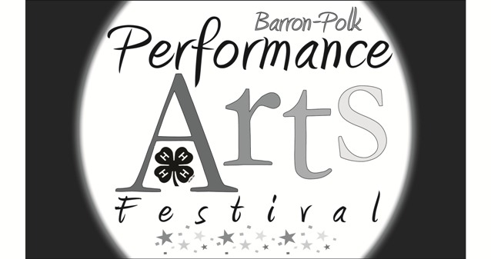
Saturday, April 18, 2020
Turtle Lake School

Group Musical Performance Entry

Clubs may have multiple Group Musical performances. Group Musical performances are not a fair entry; there is no premium. (For music fair entries, see the Musical Performance Entry form.)

- Performances may include vocals, instrumentals, and/or dance. Pantomiming or lip synching to recordings is not permitted.
- Performances must include five or more performers.
- All props will be the responsibility of the performers/directors.
- All performers and directors must be currently enrolled Barron or Polk County 4-H members/volunteers.
- No hay bales, straw bales, candles, real fires, liquids, or weapons of any kind (real or fake) will be used in performances.
- Performances should be no longer than 15 minutes in length, including set-up and take-down.
- Accompanists or directors will not be allowed to sing along with their group’s presentation.
- Groups should give a brief introduction to the musical performance to set the stage.

Name of Club: ______________________________________________ County: Barron Polk
Title of Performance: ___________________________________________________________________
Director(s): ___________________________________________ Phone: _________________________
Email: _______________________________________________
Accompanist: _________________________________________________________________________

Names of Participants:
1. | 6. | 11.
2. | 7. | 12.
3. | 8. | 13.
4. | 9. | 14.
5. | 10. | 15.

Mail to: Extension Barron County – 4-H | 335 E. Monroe Avenue, Room 2206 | Barron, WI 54812
Or email to: sara.waldron@wisc.edu
Deadline to register: April 1, 2020

