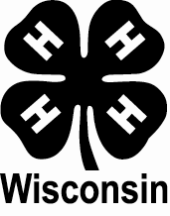
Barron County 4-H

MEMBER YEARLY RECORD/SHOWCASE
Record/Showcase Form

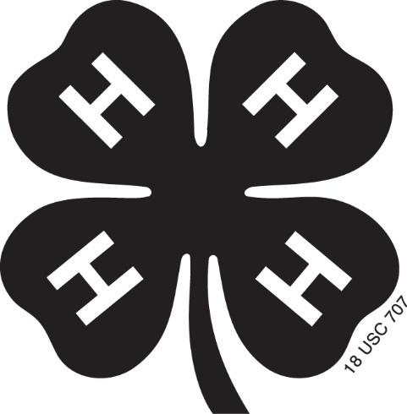

Wisconsin

Name:
County:
Club:



An EEO/AA employer, University of Wisconsin-Madison Division of Extension provides equal opportunities in employment and programming, including Title VI, Title IX, the Americans with Disabilities Act (ADA) and Section 504 of the Rehabilitation Act requirements.

Your Yearly Plan and Record
Plan the things you would like to do and learn in each project with the help of your leader and/or parents at the beginning of the year. Use the Member Planning and Evaluation Form (MPE) to record your plans. To evaluate at the end of the year, record the progress you made toward your goals (or plans) on the MPE form.

Other records you may include are:
- My 4-H Activity Program (MPE-A)
- Financial Record (FR)
- Additional Record Forms
  - As provided by your county
  - From examples in your project literature
  - Developed by you as needed
- 4-H Story for the Year
  - Include pictures to tell your story
  - A few news clippings can support your story

Below are the projects which I have carried as a 4-H member.

Name of project | Year Carried

Record of My 4-H Leadership, Service, and Activities
Delegate, trips, drama, music, service to club, committees served, performances, judging.
Leadership, Service, or Activity (Level) | Description of Leadership, Service or Activity
Activity (State Trip) | American Spirit Delegate to New York, Boston, Niagara Falls
Leadership (Club) | Club Officer - Secretary

Flag Pledge
I pledge allegiance to the flag of the United States of America, and to the republic for which it stands, one nation under God, indivisible, with liberty and justice for all.

4-H Pledge
I Pledge
...My Head to clearer thinking
...My Heart to greater loyalty
...My Hands to larger service, and
...My Health to better living, for my Club, my Community, my Country, and my World.

National Conservation Pledge
I give my pledge as an American to save and faithfully defend from waste the national resources of my country...its soil and minerals, its forests, waters, and wildlife.

4-H Club Emblem: The four-leaf clover 4-H Club Colors: Green and White
4-H Club Motto: “To Make the Best Better”

